**NAME: Brenda Chirchir  
Reg No:COM/0035/22 COURSE CODE: CSC 216**

**COURSE TITLE: DIGITAL AND ANALOG COMMUNICATION CAT 1**

1. Using suitable diagrams and equations explain how AM is achieved. (Given carrier signal is Wc MHz and information signal is Wm Khz where both waves are sinusoidal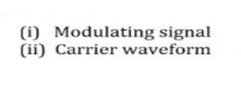

(i)   
(ii)  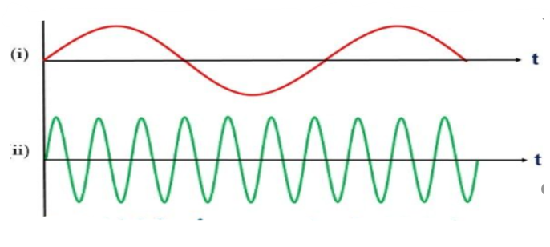

The achieved Amplitude Modulation when a carrier signal is at frequency of Wc MHz and the information signal is at Wm KHz, the process involves multiplying the carrier signal, usually at a higher frequency, with the information signal, typically a lower frequency signal.

The modulation process involves altering the amplitude of the amplitude of the carrier wave based on the variations in information signal, creating side bands around the carrier frequency that contain frequency that contain information to be transmitted. This result to AM signal.

2.State the equation for AM modulation index

The Modulation index (m) for AM is given by

M= (Ac + Am) (Ac - Am)

Where:   
Ac – carrier Amplitude  
Am – Message Signal Amplitude

3.State the equation for FM modulation index

M= Ac - Am

Ac + Am

Where:

m – Modulation Index

Ac – Amplitude of carrier signal

Am – Amplitude of modulation Signal

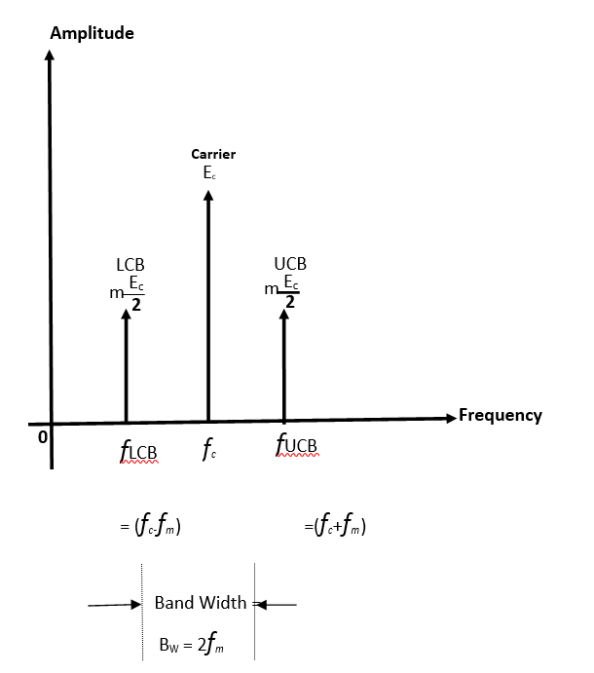

The equation of AM Wave

= Ec Cos (2wct) + (MEc/2) Cos (Wc + wm)t + (MEc/2) Cos (Wc - Wm) Carrier Signal

upper side Band

Lower side Band

Band Width = F USB – F LSB

= (fc + fm) - (fc - fm)

= 2fm

5.Draw a block diagram of CDMA spread spectrum and explain how the system operates

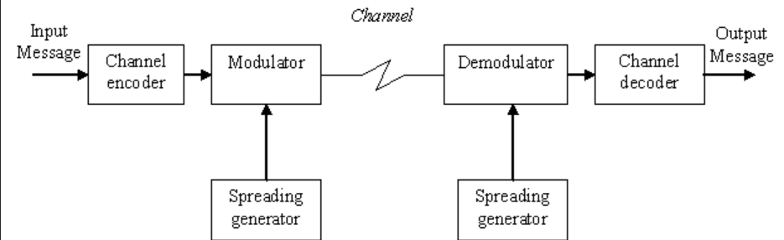

Each user in CDMA network is assigned a unique spreading code which is used to modulate user's signal hence spreading it over a wide bandwidth. This process makes the signal more resistant to interference and hence improves system capacity.

Multiple users can transmit their spread signals over the same frequency band simultaneously. This occurs due to unique codes that allows the system distinguish between them.

At the receiver's point, the incoming signal in dispreads using corresponding unique codes. Here there is separation of desired signal from other signals that share the same bandwidth.

Since CDMA is resistance to interference and user has unique code, then the signal from other users appears as noise rather than interference.

1. Differentiate between GSM technology and CDMA Technology

[6marks]

|  |  |
| --- | --- |
| GSM | CDMA |
| Utilizes time division multiple access | Employs code division Access |
| Employs a combination of frequency division Multiple access | Enables multiple users to share frequency by using different time slot |
| Offers broader handset compatibility | Has more restricted handset compatible |
| Requires SIM for user identification and authentication | Lacks SIM cards, hence user information is stored in the network |
| Facilitates better international roaming due to its global prevalence | International roaming is more limited as CDMA networks may not be as widespread globally |
| It associates with slower data speeds | It associates with potentially faster data speeds |

1. Explain about Voice Over Internet Protocol. [6marks]

Voice over international protocol is a technology that allows voice communication and multimedia sessions over internet. Instead of using traditional telephone networks, VoIPs converts Analog audio signals into digital data that can be transmitted over the internet. This enables users to make phone calls, send messages and conduct video conferences using the internet as medium.

**Advantages**

* Cost saving- as it eliminates the need for separate telephone service.
* Provides features- such as voice mail, call forwarding and video conferencing.
* Used in various devices- including computers and smartphones.
* Popular applications like WhatsApp, Skype and Zoom for communication.

1. Describe 3 types of noise in telecommunication and electronics [8marks]
   1. **Thermal noise**

It is also known as Johnson-Nyquist noise. It rises from random motion of electrons in a conductor and any finite temperature. This noise is present in all electric components and communication channels, contributing to baseline level of unwanted signal variation.

## Intermodulation noise

Occurs when multiple signals with different frequencies interacts within a nonlinear device, such as amplifier. The nonlinearities cause the generation of new frequencies that were not originally present, leading to interference and degradation of the desired signals.

## Shot noise

Stemming from the discrete nature of electric charge. It results from statistical variation in the arrival of electrons at a detector. It is particularly noticeable in devices where current flow low, such as photodetectors in optic communication systems.

1. Baseband in the transmission of communications signals means only one path is available to send and receive digital signals between devices. Describe the various ways in which baseband is used [4 marks]

## Ethernet communication

Baseband enables the transmission of digital signals across a single channel, typically using twisted -pair or fibre optic cables.

## Digital modulation

Baseband is used to directly transmit digital signals without modulation. Where the entire bandwidth of a channel is dedicated to a single data stream.

## Digital storage

Baseband is employed in digital storage devices where digital data is stored and retrieved without modulation.

## Fibre-optic transmission

Baseband allows for direct transmission of signals over optic fibres, using OOK and NRZ encoding techniques.

1. In order to transmit [computer](https://www.britannica.com/technology/computer) data and other digitized information over a communications channel, an analog carrier wave can be modulated to reflect the binary nature of the digital baseband signal. Explain ASK, FSK and PSK digital modulation techniques

[6 marks]

## Amplitude-shift keying

If amplitude is the only parameter of the carrier wave to be altered by the information signal, the modulating method is called amplitude-shift keying (ASK). ASK can be considered a digital version of analog amplitude modulation. In its simplest form, a burst of radio frequency is transmitted only when a binary 1 appears and is stopped when a 0 appears. In another variation, the 0 and 1 are represented in the modulated signal by a shift between two preselected amplitudes.

## Frequency-shift keying

If frequency is the parameter chosen to be a function of the information signal, the modulation method is called frequency-shift keying (FSK). In the simplest form of FSK signaling, digital data is transmitted using one of two frequencies, whereby one frequency is used to transmit a 1 and the other frequency to transmit a 0.

## Phase-shift keying

When phase is the parameter altered by the information signal, the method is called phase-shift keying (PSK). In the simplest form of PSK, a single radio frequency carrier is sent with a fixed phase to represent a 0 and with a 180° phase shift—that is, with the opposite polarity—to represent a 1.

1. Periodic waveforms are those that vary [periodically,](https://en.wikipedia.org/wiki/Periodic_function) they repeat regularly at consistent intervals. State 4 Parameters of Periodic Wave Forms [4 marks]

## Amplitude

1. **Frequency**

## Phase

1. **Period**

12.

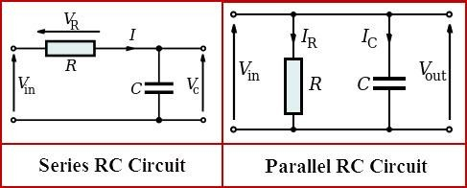

Explain how the above RC Filter works [4 marks]

**In series circuits**

In any series circuits the time used is constant. Determined by the resistor and capacitor to alter the input signal by selectively allowing certain frequencies to pass while attenuating others, thereby performing signal filtering.

**In parallel circuits**

An RC parallel circuit filters the input signal by offering different impedance paths for current flow based on the frequency of input signal, affecting the voltage drop across the components and consequently shaping the output signal.